Issue 6. April 17 2008.

‘A Joy to Watch’ announce England Selectors.

Marston & Durkin get thumbs up. The rest told: ‘You’re rubbish’.

In an appalling turn-out for last week’s O2 Broadband Super-Ladder, Phil Marston and Kev Durkin, cut through the initial disappointment of a packed West Totton Astra Dome, like Cillit Bang through ground-in dirt.
In what was described by onlookers as ‘Vintage squash’ the pair, sponsored by Gillette, put on a 5-match exhibition of so much class and style that GQ magazine’s Editor-in-chief has this week resigned, due to a massive shortfall in cool. ‘I’m nothing compared to those guys’ he whimpered to journalists. ‘Marston and Durkin not only redefined the boundaries of squash, but they may well have reinvented cool as well’. Marston eventually ran out a 3 games to 2 winner, and was full of praise for the way in which the game had been played. ‘I feel we pushed it to the edge of the envelope’ he remarked ‘I’ve truly earned my visit to Chicken Land this week’.

Squash News Honey of the Week: Gemma Atkinson.



Durkin Senior Sidelined for Rest of Season?
Doubts have been raised as to whether the famous Hagui shirt will be seen again this season, as Rich Durkin pulled out of the O2 Broadband Super-Ladder last week, with what’s thought to be ligament damage to his left ankle. After an inspired performance in the Gillette Classic, Durkin Senior had been training with local outfit Skandia FC, in a bid to push for European squash next season, but sadly sustained the injury which could now force him to play Inter-Toto Squash next term.
England selector, Mr. Scruff called the injury ‘horrific’ and stated that Durkin Senior had caught the eye of selectors just one week previously. ‘In footballing terms’, he pondered, ‘Durkin Senior is somewhat akin to Perry Groves; talented, but in danger of being perennially injured’.
The next few weeks are crucial, with Durkin due to be spending up to 18 hours a day in an oxygen tank, much like hero Barry Venison once did, to aid recovery.

Pollinger: AWOL in Brighton. Will the Gay-Love Ever Stop?
Dan Pollinger, supposedly promoting Squash News to the good people of Brighton has not been spotted since last Friday night, sources close to The West Totton Astra Dome say.
Having been granted special dispensation, on the grounds of ‘Widening the audience of the greatest squash publication of all time’, Pollinger set off for the seaside town last Tuesday, but did not attend the news conference that evening. Rumours have been rife, that the Browning man has been frequenting late-night Thai massage parlours and underground clubs, with local immigrant Ting-Tong, as he fights to overcome the shame of no longer playing with Prince™ equipment.
In an emotional appeal, girlfriend Emma Brunton appeared on Squash TV and asked her man to ‘Kindly get his arse home’. More news is expected ahead of the ‘Chicken Land Battle for Supremacy’, this Thursday.

Buckley in Sri Lankan Squash Rehab Clinic:
Tommi Buckley has pulled out of all competition for the foreseeable future, and checked himself into the Jahangir Khan Clinic for Victims of Squash Burnout. In an emotional farewell, Buckley told Squash News that the ‘Battle to be the Best of the Best had taken its toll in recent weeks’ and that he ‘Needed time away from the media circus surrounding West Totton.’
It seems as though Buckley, West Totton’s newest recruit, is fast learning that it takes a lot to lift weights in a gym, but to shine on the hallowed courts of the Astra Dome, requires something altogether more special.
Everyone at the Dome wishes him a speedy recovery.

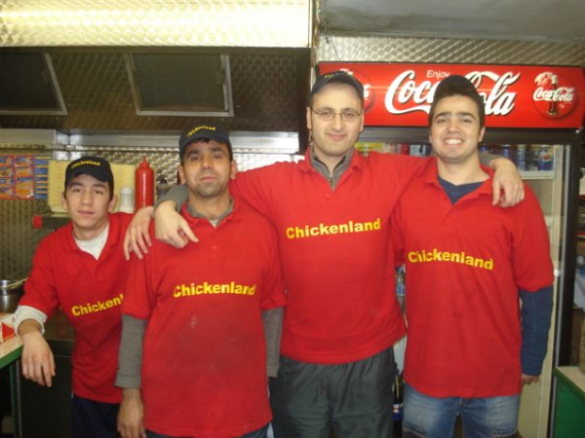
This week’s sponsors: Chickenland.
Food of Champions
& Official Snack of West Totton ’08.

Keep it locked to Squash News. More insights from the Arena next week.

